RAIN GARDEN Q&A:
Common questions asked about rain gardens!
Q: How do rain gardens work?
A: Rain gardens are bioretention areas that are designed to collect and treat stormwater runoff.
Stormwater runoff mainly comes from:
- Sidewalks - Sports fields
- Roads - Gravel lots
- Roofs - Parking areas
Washington rain can be intense at times, and the pounding of rain picks up and mixes with what’s on the ground:
- Soaps from car washing or equipment washing.
- Harmful pesticides, harsh chemicals, and fertilizer.
- Oil, grease, metals and coolants form vehicles.
Rain gardens are a cost-effective solution to treat stormwater runoff by filtering out pollutants in runoff and provide homes/shelter for butterflies, birds and other wildlife.

Q: Are native or non-native plants better for rain gardens?
A: Native plants have adapted overtime and are easier to maintain than non-native species.
Yet, it’s not realistic to not include non-native plants because of growth limitations associated with certain planting sites. If a plant can succeed on your specific planting site and is not deemed as invasive, a plant should be considered.

Q: Do rain gardens require a site assessment?
A: Yes, and no.
Washington State does not require a permit for voluntary curbside rain gardens such as those installed by homeowners.
A permit could be needed when the rain garden is installed on a development or construction project.
For homeowners, a basic assessment is needed. This will help ensure that plants are well suited to the specific microclimate, soil condition, sun exposure, and the hardiness zone of site.
More information on a proper site assessment checklist: https://www.nrcs.usda.gov/sites/default/files/2022-10/RAIN_GARDEN_SITE_ASSESSMENT_CARD.pdf

Q: What kind of maintenance does a rain garden need?
A: Depends on the plants you have in your garden. Overall maintenance is low when using woody plants which generally require less maintenance than if you used herbaceous plants. Why?
Woody plants have lignified tissues that provide strength and support – this allows them to withstand environmental stressors. Such as extreme weather changes.
Life spans can range from decades to centuries. Woody plants further survive winter or dry season above ground, as opposed to herbaceous plants that die back to the ground, until springtime comes around.
Herbaceous plants are extremely fast growing and produce many seedlings within a short duration. Herbaceous plants can be classified as:
- Annuals: Complete their life cycle in one year, dying back after flowering.
- Biennial: This plant only lives for two years. First season: produce roots, stems, and leaves. Second season is mostly shooting production and growth such as flowers.
- Perennial: non-woody plants that die back to the ground each winter. New stems grow from the plants crown around springtime. These plants can live for more than two years.

Regular maintenance tasks:
- Regular wedding throughout the establishment period. (When plants are still growing)
How to carefully prune away dead leaves from plants

Examine plants regularly for any leaves or stems that are:
- Brown, yellow or wilted
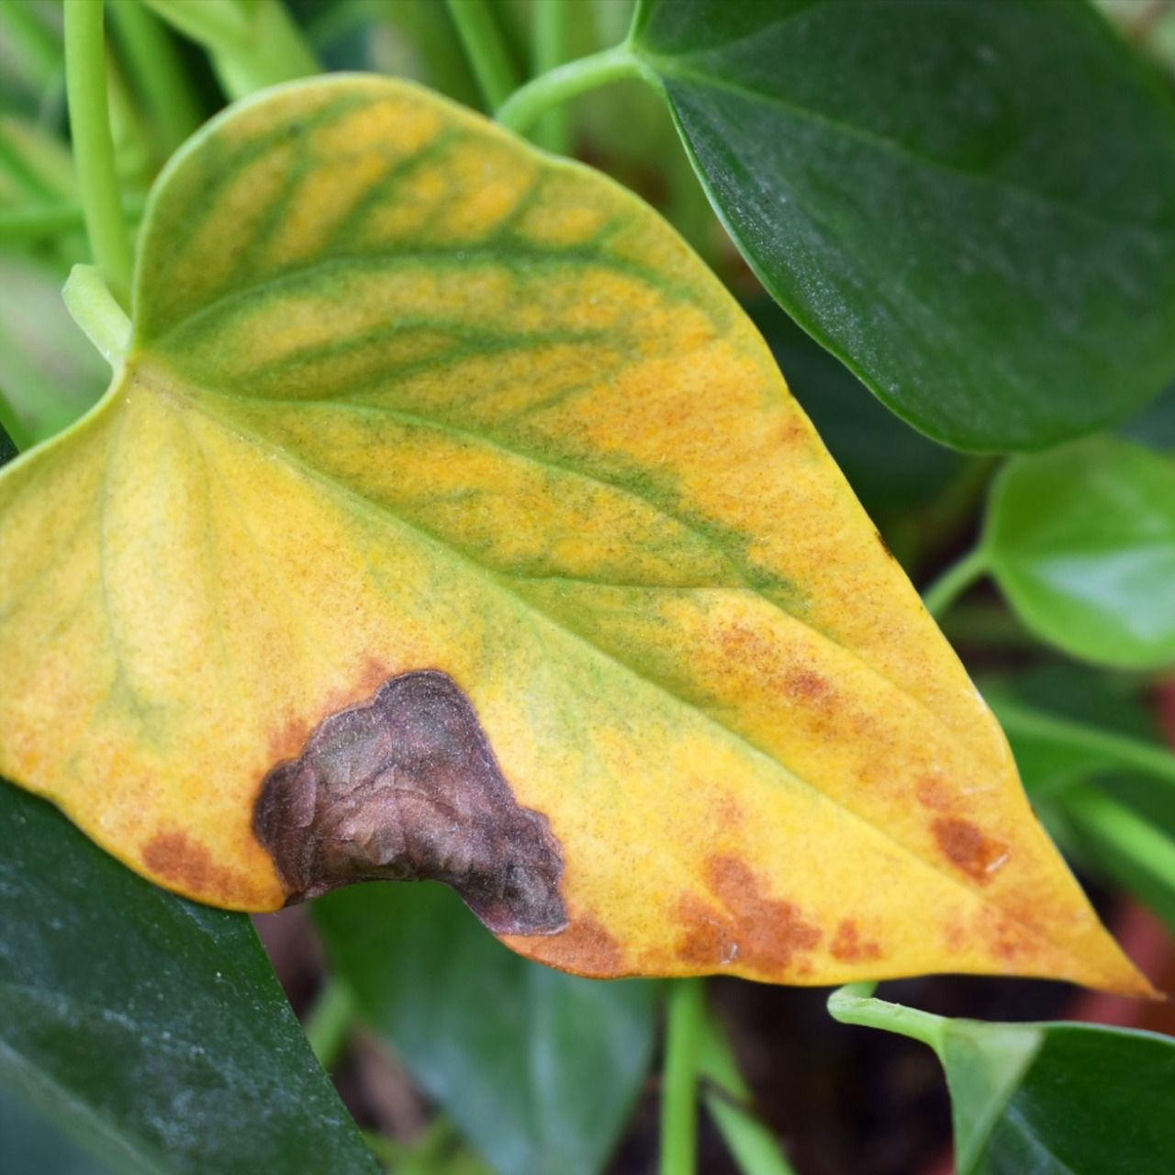
- Crispy shriveling or thin
- Drooping down or sagging
- Broken or split
- Fungus sightings or mold
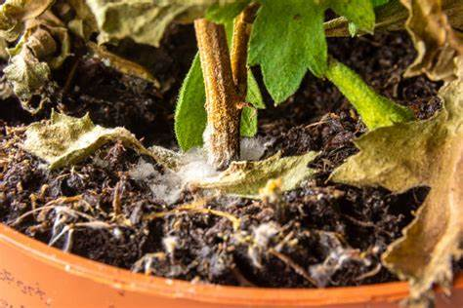
Tools:
- Sharp gardening scissors.
- Long-handled loppers (thicker stems)
How: Use sharp scissors to cut along the edges of brown or damaged leaves. Be gentle and aim for a 45-degree angle (allows the plant to heal faster).
Remove heavily damaged leaves. If a leaf is more than half dried out or browned, it is better to cut it off completely. Snip it at the base of the stem where it connects to branch.

- Yearly mulching of established plantings
- Pruning of dead, damaged, diseases of branches and foliage.

Q: What are common plants used in rain gardens in Washington State?
A: Here are 2 of the most common plants used in rain gardens.
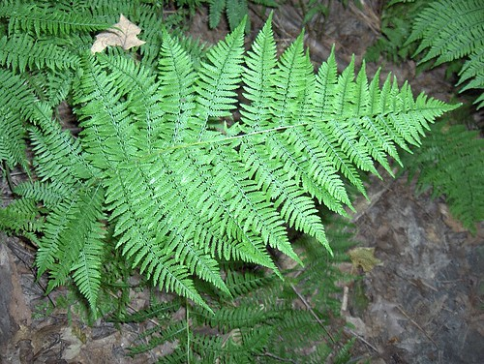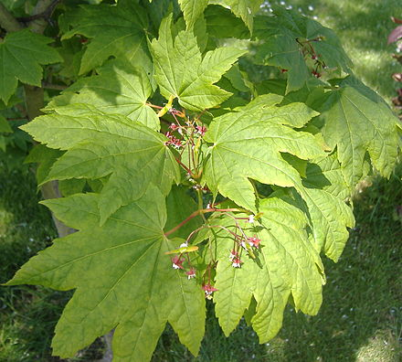
This Photo Lady Fern: Native to the PNW, thrives in coastal areas to inland forests. Often used as ground cover.
This Photo Vine Maple: Native to the PNW and thrives in moist shaded areas. Highly adaptable.

