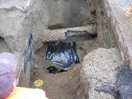
NE 181st Street Culvert Replacement
2008-2012
Budget: $817,600
In May 2008, a sinkhole developed in the NE 181st St roadway over the Tributary 0056 culvert crossing. Due to the structural deterioration of the culvert, an emergency permit was issued and the culvert was replaced with a fish-passable box culvert.

